The Liaohekou wetland dataset was acquired using the hyperspectral imagery collected by the ZY-1 02D optical satellite over the Liaohekou Wetland National Nature Reserve in Panjin City, China. The data were obtained in September 2020, with a spatial resolution of 30 m. The spectral resolutions in the near-infrared (NIR) and short-wave infrared (SWIR) regions are 10 nm and 20 nm, respectively. The reference labels were generated based on field sampling points.
The spectral range of the dataset covers 400–2500 nm. After removing bands severely affected by noise and atmospheric water vapor absorption, 117 valid spectral bands were retained. The image size is 1660 × 1517 pixels, with a total data volume of 221 MB. After excluding background pixels, 382,581 labeled pixels are available for classification.
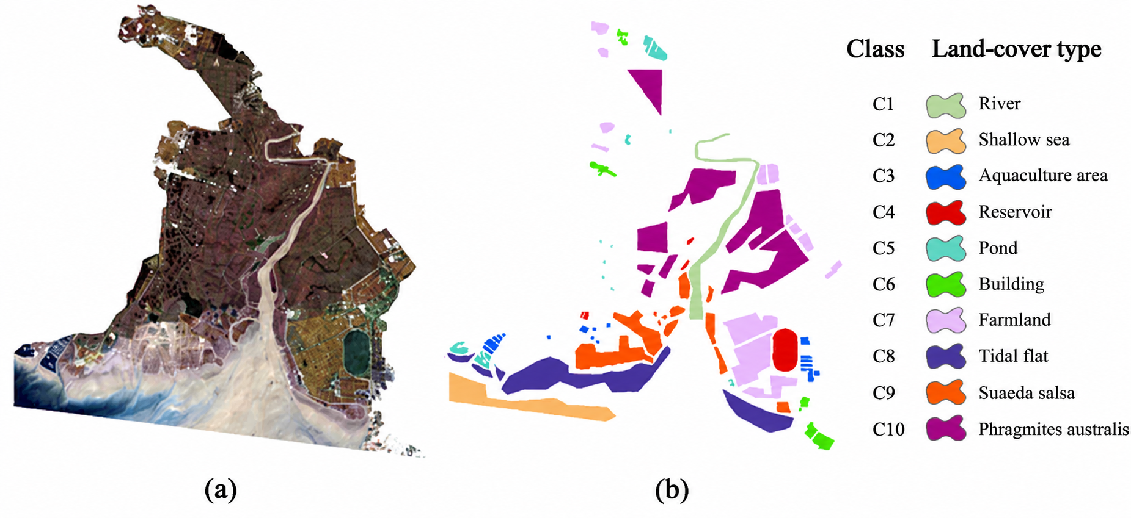
Figure 1. Spatial distribution of the Liaohekou wetland dataset. (a) False-color composite image. (b) Reference classification map.
The dataset contains 10 land-cover categories, including typical wetland vegetation types such as Phragmites australis (reed) and Suaeda salsa (alkali grass), as well as agricultural land. Since the study area is located in a sedimentary plain estuary, the land–sea interaction zone contains extensive tidal flats. In addition, the river water is highly turbid, resulting in significant spectral similarities among seawater, aquaculture areas, ponds, and reservoirs.
As shown in Fig. 1, except for ponds, most land-cover types exhibit relatively clustered spatial distributions, while rivers show irregular geometric shapes. The numbers of samples collected for each land-cover category are listed in Table 1.

Table 1. Sample details of the Liaohekou dataset
Class | Land-cover type | Number of samples
C1 | River | 21,552
C2 | Shallow sea | 36,483
C3 | Aquaculture area | 8,170
C4 | Reservoir | 15,299
C5 | Pond | 9,420
C6 | Building | 9,814
C7 | Farmland | 60,968
C8 | Tidal flat | 68,268
C9 | Suaeda salsa | 47,690
C10 | Phragmites australis | 104,917

